**Indira College Of Commerce**

**And Science (Wakad)**



**Spare Part Management System**

**TYBCA-Sem VI**

**Year 2015-16**

* **Submitted To:**
* **Prof. ShivenduBhushan**
* **Prof. ShubhangiChavan**
* **Developed By:**
* **SwapnilWani**
* **DevendraBhoge**

|  |  |  |  |
| --- | --- | --- | --- |
| **Sr.No** |  | **Particulars** | **Page No.** |
| **A)** |  | **Introduction** |  |
|  | **1)** | Title of Project |  |
|  | **2)** | Existing System | **3** |
|  | **3)** | Proposed System | **4** |
|  | **4)** | Advantages of proposed System | **5** |
|  | **5)** | Hardware/Software Requirement | **6** |
|  | **6)** | Feasibility Study | **7** |
| **B)** |  | **Analysis** |  |
|  | **1)** | ERD | **8** |
|  | **2)** | CLD | **9** |
|  | **3)** | DFD | **10** |
|  | **4)** | File Design / Normalized database | **12** |
|  | **5)** | Data Dictionary | **21** |
|  |  |  |  |
| **C)** |  | **Design** |  |
|  | **1)** | Input Screen (Without Data) | **27** |
|  | **2)** | Output Screen (With Data) | **41** |
|  | **3)** | Reports | **50** |
| **D)** |  | **Code Design(Sample Code)** | **57** |
| **E)** |  | **Limitations Of the System** | **63** |
| **F)** |  | **Conclusion** | **64** |
| **G)** |  | **Future Enhancement** | **65** |
| **H)** |  | **Bibliography** | **66** |

INDEX

**Synopsis**

**Project: Spare Part Management System**

|  |
| --- |
| **Title:- Spare Part Management System** |

* **Introduction:**

In **Spare Part Management System** our main aim is to satisfy the user needs regarding the Sales & Purchase Items. This project will be user friendly and will help the user to Order Spare Parts.

Through this project Customer can Order their product from any location and can place their query as per their requirements and get results immediately on particular Order as per their directed location and as per entered price.

Through our system,time is utilized, paper work and human efforts have been reduced. This project will keep records of customers and their details, payment Record Order ,Raw Items Record, Finished Goods (Items ) available StockRecords and many more details.

* **Existing System:**
* The existing system of Spare Part Management System is based on human efforts. The Industry was mainly deals in Spare part. The industry has very large business and continuously growing. The working of organization was mainly based on the purchase of the raw material in various forms and then it is get processed in the work shop through a very large machines.
* Other than that to maintain the records of day to day transaction manually is what makes the process time consuming
* All the transaction to be maintained in this process is done on paper, records like entering details, payment entries, availability etc are all done manually and are recorded on paper
* So, to reduce the human efforts and save time we need to computerize the existing process .
* **Proposed System**
* Integrated collection of information
* One entry will automatically propagate the rest of its references in other activity.
* It will cover almost all activity regarding the sale and purchase matter.
* The software will ensure the reports are not visible to the end users making only data entry
* The proposed system will carry all the burdens of keeping the stock of goods and raw material.
* It will speed up the working of organization.
* **Advantages of Proposed System:**
* Easy maintenance of information
* No dependency on a specific person to get a required information
* Saves time and efforts
* Reduces paperwork
* Automatic generation of Bill
* Less possibility of data loss
* **Scope of project**
* Each & every record of customer are maintained.
* Maintain stock for every sell & purchase of raw materials and product.
* Inserted records are able to handle to managerial person.
* Bill maintains & generated in system according to transactions.
* Calculations generated fastly with accuracy.
* **Hardware Requirements:**
* Processor: Intel core i3 1.80GHz
* RAM: 2GB
* Monitor: LCD Monitor
* Keyboard: Normal
* Mouse Compatible Mouse
* **Software Requirements:**
* Operating System: Windows XP/2000 or higher version.
* Front End: Dot Net Programming
* Back End: SQL.
* **Feasibility Study:-**

The initial investigation points to the question whether the project is feasible. A feasibility us conducted to identity the best system that meets the all the requirements. This includes an identification description, an evaluation of the proposed systems and selection of the best system for the job.

The requirements of the system are specified with a set of constraints such as system objectives and the description of the outputs. It is then duty of the analyst to evaluate the feasibility of the proposed system to generate the above results. Three key factors to be considered during the feasibility study.

1. Operation Feasibility

An estimate should be made to determine how much effort and care will go into the developing of the system including the training to be given to the user. Usually, people are reluctant to changes that come in their progression. The computer initialization will certainly affected the turn over, transfer and employee job status.

Hence an additional effort is to be made to train and educate the users on the new way of the system.

2. Technical Feasibility

The main consideration is to be given to the study of available resources of the organization where the software is to be implemented. Here the system analyst evaluates the technical merits of the system giving emphasis on the performance, Reliability, Maintainability and productivity.

By taking the consideration before developing the proposed system, the resources availability of the organization was studied.

3. Economical Feasibility

Economical feasibility is the most important and frequently used method for evaluating the effectiveness of the proposed system. It is very essential because the main goal of the proposed system is to have economically better result along with increased efficiency. Cost benefit analysis is usually performed for this proposes. It is the comparative study of the cost verses the benefit and savings that are expected from the proposed system. Since the organization is well equipped with the required hard ware, the project was found to be economically

**Entity-Relationship Diagram**

MM

MM

1

**Product**

Pays

**Employee**

1M

MM

1M

1M

1M

MM

**M**

M

Has

Pays

Place

**Generate**

Pays

Receives

**Cust_Bill**

**Customer**

**Order**

Consist

Handles

**Employee**

Supplies

MM

1M

1M

**Supplier**

1M

**Bill**

1M

MM

MM

1M

**Context Level Diagram**

**FIRST LEVEL DIAGRAM**

Response Request

Supplier Details

Organization Details

Customer Details

Send Request

Supplier Details

Organization Details

Customer Details

**Admin**

**Supplier**

**Organization**

**Customer**

**Admin**

**Supplier**

**Organization**

**Customer**

Access

Username & Password

User name & Password

**Login Details**

**Employee**

Validated Login Details

Product details

Product Details

Product Enquirydetails

**Product Details**

Product Details

**Employee**

Enquiry details

**Employee Details**

**Customer**

Product Enquiry

Feedback

Stock Updates

Product, Payment Bill

Updated Stock details

**Stock Details**

**Customer Details**

**Customer**

Customer Details

Payment details

Customer Details, Payment

Updating Payment details

**Payment Details**

**Employee**

Customer Details, Payment details

Updated Stock Details

Validated Stock Details

**Stock Details**

Stock Details

**Employee**

Updating Stock Details

Order details

Order details, Supplier Details

Order details

**Employee**

**Order Details**

Order Details

**Supplier**

Supplier details

**Supplier Details**

Order Details

Supplier details

Receive Payment

**Supplier**

Order Details

Send Acknowledgment

Pay Bill

Bill Details

Customer Details

Employee Details

**Customer**

**Employee**

**Order Details**

Updating Stock Details

Order details, Payment Receipt

**Stock Details**

Raw Materials

Stock Updated

**Employee**

Order details, Updated Stock Details

Bill Details

Bill Details

Receive Payment Receipt

**Customer**

Pay Amount

Generate Bill

Payment Details

Customer Details

Supplier Details

Queries

Reports

Order Details

Payment

**Supplier**

Login Details

Customer Details

Supplier Details

Order Details

Payment Details

Stock Details

Admin

Login Details

Order Details

Stock Details

**Product Details**

Updated Stock Details

Acknowledgement

A

**Employee**

**Payment Details**

Payment Details

Payment Details, Updated Stock Details

Database Design

The system will have following database tables.

Table: spProductMaster

|  |  |  |  |  |
| --- | --- | --- | --- | --- |
| **Sr.no** | **Field Name** | **Data Type** | **Width** | **Constraints** |
| 1 | Product Code | Integer | 4 | Primary Key |
| 2 | Product Name | Varchar | 50 | Not Null |
| 3 | Description | Varchar | 70 | Not Null |
| 4 | Catalog code | Varchar | 20 | Not Null |
| 5 | Sale rate | Float | (8,2) | Not Null |
| 6 | Stock | Integer | 4 | Not Null |

|  |  |  |  |  |
| --- | --- | --- | --- | --- |
| **Sr.No** | **Field Name** | **Data Type** | **Width** | **Constraints** |
| 1 | Customer Code | Integer | 4 | Primary Key |
| 2 | Customer Name | Varchar | 60 | Not Null |
| 3 | Address | Varchar | 100 | Not Null |
| 4 | City | Varchar | 30 | Not Null |
| 5 | Cell Number | Integer | 20 | Null |
| 6 | Email | Varchar | 50 | Null |

Table: SpCustomerMaster

|  |  |  |  |  |
| --- | --- | --- | --- | --- |
| **Sr.No** | **Field Name** | **Data Type** | **Width** | **Constraints** |
| 1 | Supplier Code | Integer | 4 | Primary Key |
| 2 | Supplier Name | Varchar | 60 | Not Null |
| 3 | Address | varchar | 100 | Not Null |
| 4 | City | varchar | 30 | Not Null |
| 5 | Cell Number | Integer | 20 | Null |
| 6 | Email | varchar | 50 | Null |

Table :spSupplier_Master

Table: sprawMaterial

|  |  |  |  |  |
| --- | --- | --- | --- | --- |
| **Sr.No** | **Field Name** | **Data Type** | **Width** | **Constraints** |
| 1 | Raw Product Code | Integer | 4 | Primary Key |
| 2 | Raw Product Name | Varchar | 50 | Not Null |
| 3 | Raw Catalog code | Varchar | 20 | Not Null |
| 4 | Raw stock | Integer | 4 | Not Null |

Table: spOrdermaster

|  |  |  |  |  |
| --- | --- | --- | --- | --- |
| **Sr.No** | **Field Name** | **Data Type** | **Width** | **Constraints** |
| 1 | Order Code | Integer | 4 | Primary Key |
| 2 | Order date | Date | - | Not Null |
| 3 | Expected date | Date | - | Not Null |
| 4 | Customer Name | Varchar | 4 | Not Null |
| 5 | Reference number | Varchar | 30 | Not Null |
| 6 | Delivery Date | Date | - | Not Null |

**Table:** OrderTransaction

|  |  |  |  |  |
| --- | --- | --- | --- | --- |
| **Sr.No** | **Field Name** | **Data Type** | **Width** | **Constraints** |
| 1 | Order Code | Integer | 4 | Foreign Key |
| 2 | Product code | Integer | 4 | Foreign Key |
| 3 | Quantity | Integer | 4 | Not Null |

Table :ProductionMaster

|  |  |  |  |  |
| --- | --- | --- | --- | --- |
| **Sr.No** | **Field Name** | **Data Type** | **Width** | **Constraints** |
| 1 | Transaction code | Integer | 4 | Primary Key |
| 2 | Product code | Integer | 4 | Foreign Key |
| 3 | Production date | Date | - | Not Null |
| 4 | quantity | Integer | 4 | Not Null |

Table :ProductionTransaction

|  |  |  |  |  |
| --- | --- | --- | --- | --- |
| **Sr.No** | **Field Name** | **Data Type** | **Width** | **Constraints** |
| 1 | pSrNo | Integer | 2 | Primary Key |
| 2 | Transaction code | Integer | 4 | Foreign Key |
| 3 | Product code | Integer | 4 | Foreign Key |
| 4 | quantity | Integer | 4 | Not Null |

Table :PurchaseMaster

|  |  |  |  |  |
| --- | --- | --- | --- | --- |
| **Sr.No** | **Field Name** | **Data Type** | **Width** | **Constraints** |
| 1 | Purchase Code | Integer | 4 | Primary Key |
| 2 | Purchase date | Date | - | Not Null |
| 3 | Supplier Name | Varchar | 60 | Not Null |
| 4 | Bill  Number | Varchar | 30 | Not Null |

Table: PurchaseTransaction

|  |  |  |  |  |
| --- | --- | --- | --- | --- |
| **Sr.No** | **Field Name** | **Data Type** | **Width** | **Constraints** |
| 1 | Purchase Code | Integer | 2 | Foreign Key |
| 2 | Product code | Integer | 4 | Foreign Key |
| 3 | Quantity | Integer | 4 | Not Null |

**Table:SaleMaster**

|  |  |  |  |  |
| --- | --- | --- | --- | --- |
| **Sr.No** | **Field Name** | **Data Type** | **Width** | **Constraints** |
| 1 | Bill Number | Integer | 4 | Primary Key |
| 2 | Bill date | Date | - | Not Null |
| 3 | Customer Code | Integer | 4 | Foreign Key |
| 4 | Order code | Integer | 4 | Foreign Key |
| 5 | Vat | Float | - | Not Null |
| 6 | Transport | Float | - | Not Null |
| 7 | Total Amount | Float | - | Not Null |

Table : Table SaleTransaction

|  |  |  |  |  |
| --- | --- | --- | --- | --- |
| **Sr.No** | **Field Name** | **Data Type** | **Width** | **Constraints** |
| 1 | pSrNo | Integer | 4 | Foreign Key |
| 2 | Bill Number | Integer | 2 | Foreign Key |
| 3 | Product Code | Integer | 4 | Foreign Key |
| 4 | Quantity | Integer | 4 | Not Null |
| 5 | Rate | float | - | Not Null |
| 6 | Amount | Float | - | Not Null |

**DATA DICTIONARY**

|  |  |  |  |  |  |  |
| --- | --- | --- | --- | --- | --- | --- |
| **Sr.no** | **Field Name** | **Data Type** | **Width** | **Constraints** | **Data Description** | **Table Name** |
| 1 | Product Code | Integer | 10 | Primary Key, Order Transaction, Production Master,PurchaseTransaction,Total sale Transaction | The primary Key of this Table | ProductMaster |
| 2 | Product Name | Varchar | 50 | Not Null | The actual Item type | ProductMaster |
| 3 | Description | Varchar | 70 | Not Null | This field will decide if the item type is for raw material or for finished goods | ProductMaster |
| 4 | Catlog code | Varchar | 20 | Not Null | Catlog Code | ProductMaster |
| 5 | Sale rate | Float | (8,2) | Not Null | The actual Cost of product | ProductMaster |
| 6 | Stock | Integer | 4 | Not Null | Display Product Stock | ProductMaster |
| 7 | Customer Code | Integer | 4 | Primary Key,Sale Master | The primary Key of this Table | CustomerMaster |
| 8 | Customer Name | Varchar | 60 | Not Null | Defines Customer Name | CustomerMaster |
| 9 | Address | Varchar | 100 | Not Null | Address of Customer | CustomerMaster |
| 10 | City | Varchar | 30 | Not Null | Customer City | CustomerMaster |
| 11 | Cell Number | Integer | 20 | Null | Customer Cell no | CustomerMaster |
| 12 | Email | Varchar | 50 | Null | Customer Email ID | CustomerMaster |
| 13 | Supplier Code | Integer | 4 | Primary Key, Total Sale Transaction | The primary Key of this Table | Supplier_Master |
| 14 | Supplier Name | Varchar | 60 | Not Null | Supplier Name | Supplier_Master |
| 15 | Address | Varchar | 100 | Not Null | Supplier Address | Supplier_Master |
| 16 | City | varchar | 30 | Not Null | Supplier Address | Supplier_Master |
| 17 | Cell Number | Integer | 20 | Null | Supplier Cell no | Supplier_Master |
| 18 | Email | varchar | 50 | Null | Supplier E-Mail ID | Supplier_Master |
| 19 | Product Code | Integer | 4 | Primary Key, Total sale Transaction | The primary Key of this Table | RawMaterial |
| 20 | Product Name | Varchar | 50 | Not Null | Name Of Product | RawMaterial |
| 21 | Catlog code | Varchar | 20 | Foreign Key | Catlog Code | RawMaterial |
| 22 | stock | Integer | 4 | Not Null | Product stock | RawMaterial |
| 23 | Order number | Integer | 4 | Primary Key, ,Sale Master, Order Transaction | The primary Key of this Table | Ordermaster |
| 24 | Oder date | Date | - | Not Null | Order Date | Ordermaster |
| 25 | Expected date | Date | - | Not Null | Accepts Expected date | Ordermaster |
| 26 | Customer Name | Integer | 4 | Not Null | Customer Code | Ordermaster |
| 27 | Reference number | Varchar | 30 | Not Null | Reference Number | Ordermaster |
| 28 | Delivery Date | Date | - | Not Null | Date at which the product Deliver | Ordermaster |
| 29 | Srno | Integer | 2 | Primary Key, Production Transaction | The primary Key of this Table | orderTransaction |
| 30 | Order number | Integer | 4 | Foreign Key | The Foreign Key of this Table | orderTransaction |
| 31 | Product code | Integer | 4 | Foreign Key | The Foreign Key of this Table | orderTransaction |
| 32 | quantity | Integer | 4 | Not Null | Item Quantity | orderTransaction |
| 33 | Transaction code | Integer | 4 | Primary Key, Production Transaction, Purchase Master ,Purchase Transaction | The primary Key of this Table | ProductionMaster |
| 34 | Product code | Integer | 4 | Not Null | Product Code | ProductionMaster |
| 35 | Production date | Date | - | Not Null | Production Date | ProductionMaster |
| 36 | quantity | Integer | 4 | Not Null | Production Quantity | ProductionMaster |
| 37 | pSrNo | Integer | 2 | Primary Key, Production Transaction | The primary Key of this Table | ProductionTransaction |
| 38 | Transaction code | Integer | 4 | Foreign Key | The Foreign Key of this Table | ProductionTransaction |
| 39 | Product code | Date | 4 | Foreign Key | The Foreign Key of this Table | ProductionTransaction |
| 40 | quantity | Integer | 4 | Not Null | Defines Quantity | ProductionTransaction |
| 41 | Transaction Code | Integer | 4 | Foreign Key | The primary Key of this Table | PurchaseMaster |
| 42 | Purchase date | Date | - | Not Null | Raw Material Purchase Date | PurchaseMaster |
| 43 | Supplier Name | Varchar | 60 | Not Null | Supplier Name | PurchaseMaster |
| 44 | Bill  Number | Varchar | 30 | Not Null | Item bill Number | PurchaseMaster |
| 45 | Transaction Code | Integer | 4 | Foreign Key | Defines Transaction Code | PurchaseTansaction |
| 46 | SrNo | Integer | 2 | Foreign Key | The Foreign Key of this Table | PurchaseTansaction |
| 47 | Product code | Integer | 4 | Foreign Key | The Foreign Key of this Table | PurchaseTansaction |
| 48 | Quantity | Integer | 4 | Not Null | Product Quantity | PurchaseTansaction |
| 49 | Bill Number | Integer | 4 | Primary Key, Total sale transaction | The primary Key of this Table | SaleMaster |
| 50 | Billdate | Date | - | Not Null | Bill Date of Product | SaleMaster |
| 51 | Customer Code | Integer | 4 | Foreign Key | Customer Code | SaleMaster |
| 52 | Order code | Integer | 4 | Foreign Key | Order Code Of Order Master | SaleMaster |
| 53 | Vat | Float | - | Not Null | Vat On Product Amount | SaleMaster |
| 54 | Transport | Float | - | Not Null | Transport  Product | SaleMaster |
| 55 | Total Amount | Float | - | Not Null | Total Amount on Order | SaleMaster |
| 57 | Bill Number | Integer | 4 | Foreign Key | The Foreign Key of this Table | SaleTransaction |
| 58 | pSrNo | Integer | 2 | Foreign Key | The Foreign Key of this Table | SaleTransaction |
| 59 | Product Code | Integer | 4 | Foreign Key | The Foreign Key of this Table | SaleTransaction |
| 60 | Quantity | Integer | 4 | Not Null | Quantity of Order | SaleTransaction |
| 61 | Rate | float | - | Not Null | Rate of Order Prduct | SaleTransaction |
| 62 | Amount | Float | - | Not Null | Total Amt | SaleTransaction |

* Design:-

INPUT SCREEN

1. Customer Master Settings

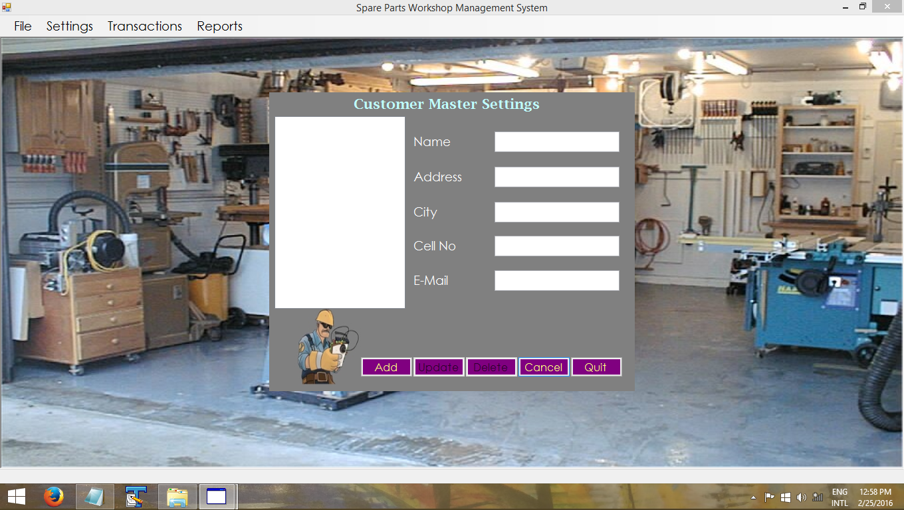

1. Item Master Settings

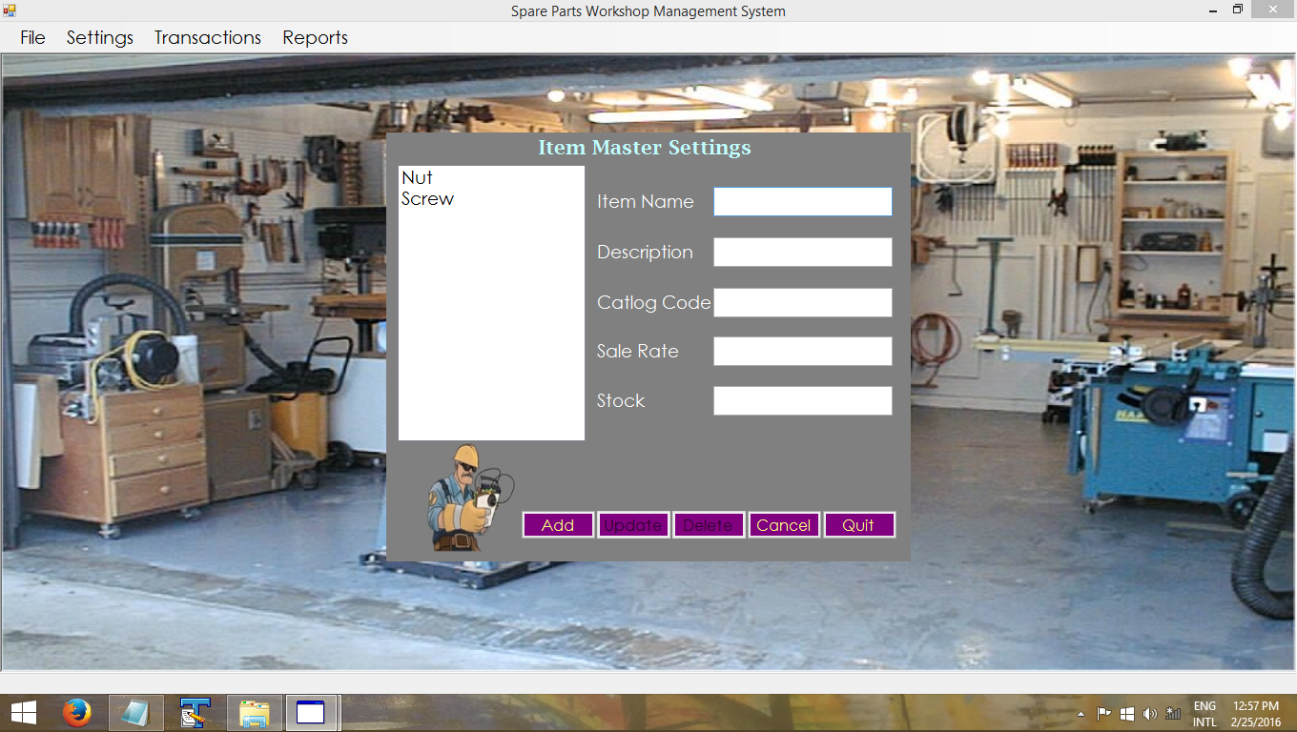

1. Raw Material Master

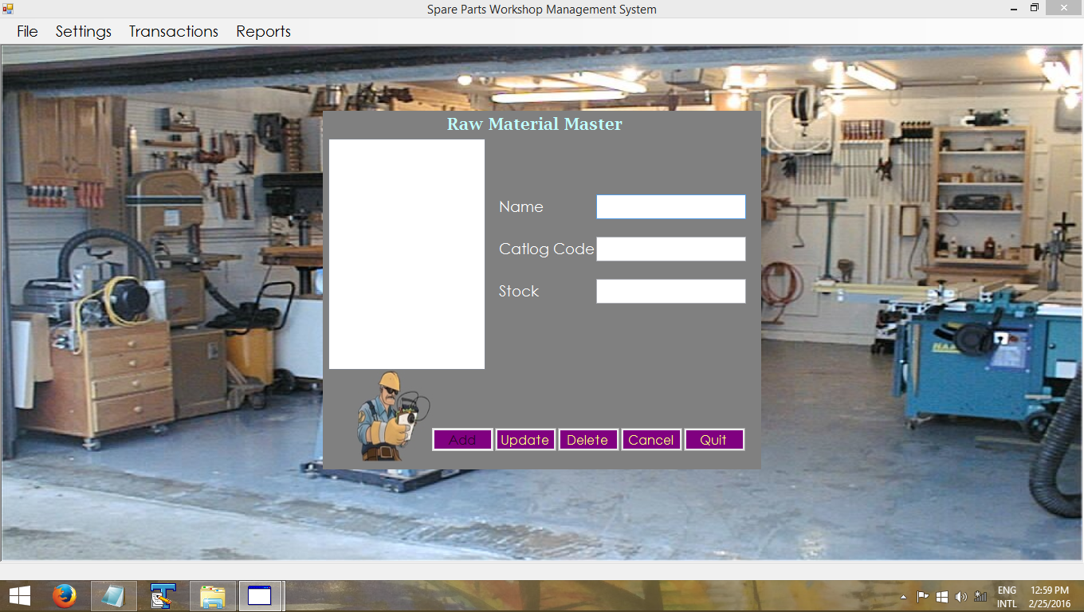

1. Supplier Master Settings

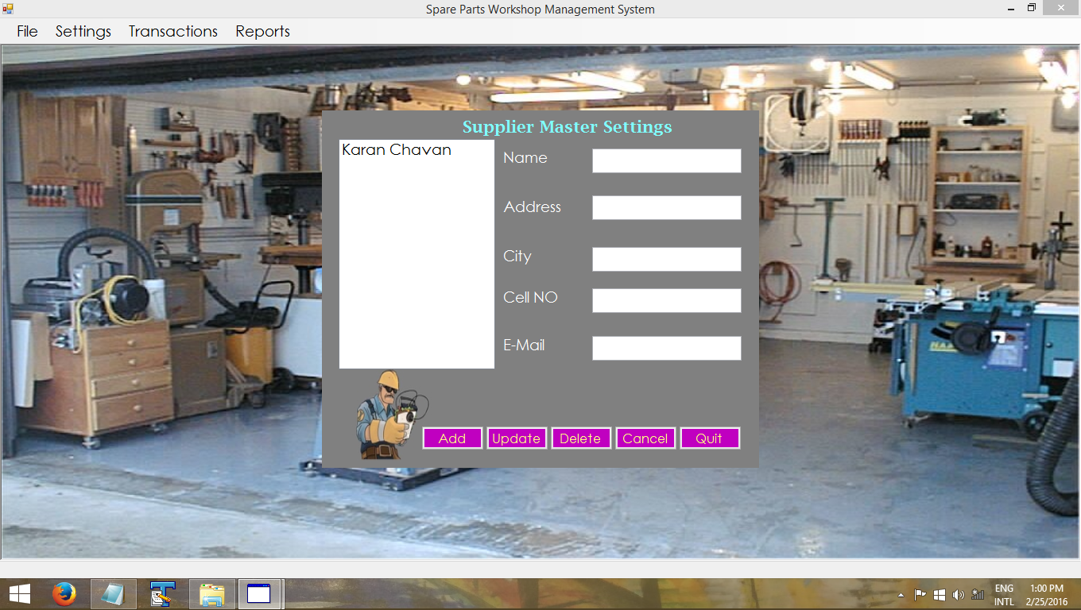

1. Order Transactions Form

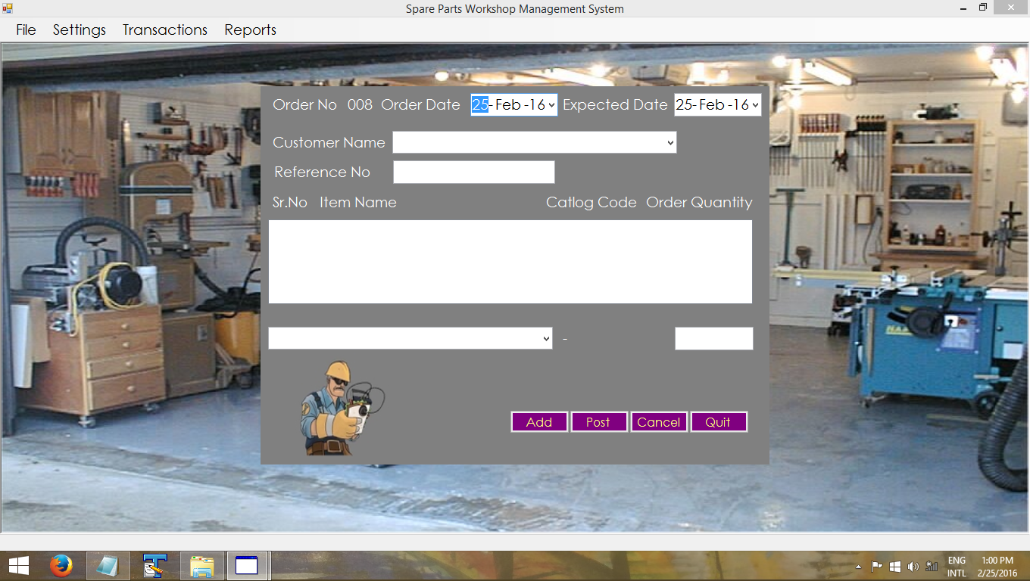

1. Sale Bill Form

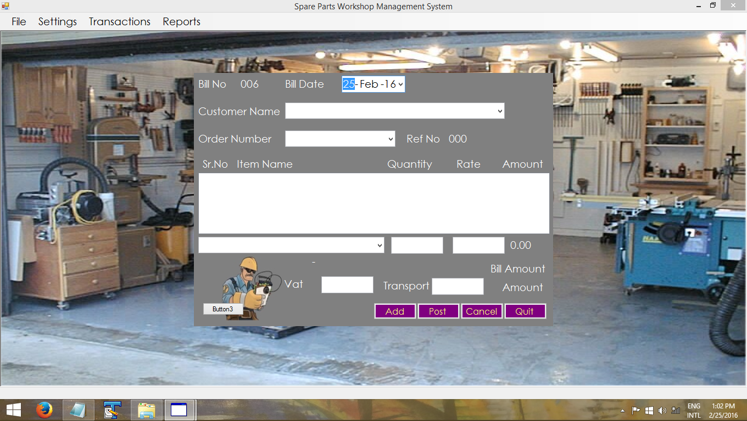

1. Raw Material Purchase

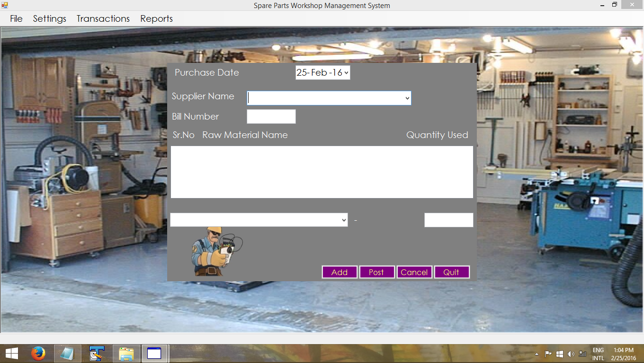

1. Sale Update Bill

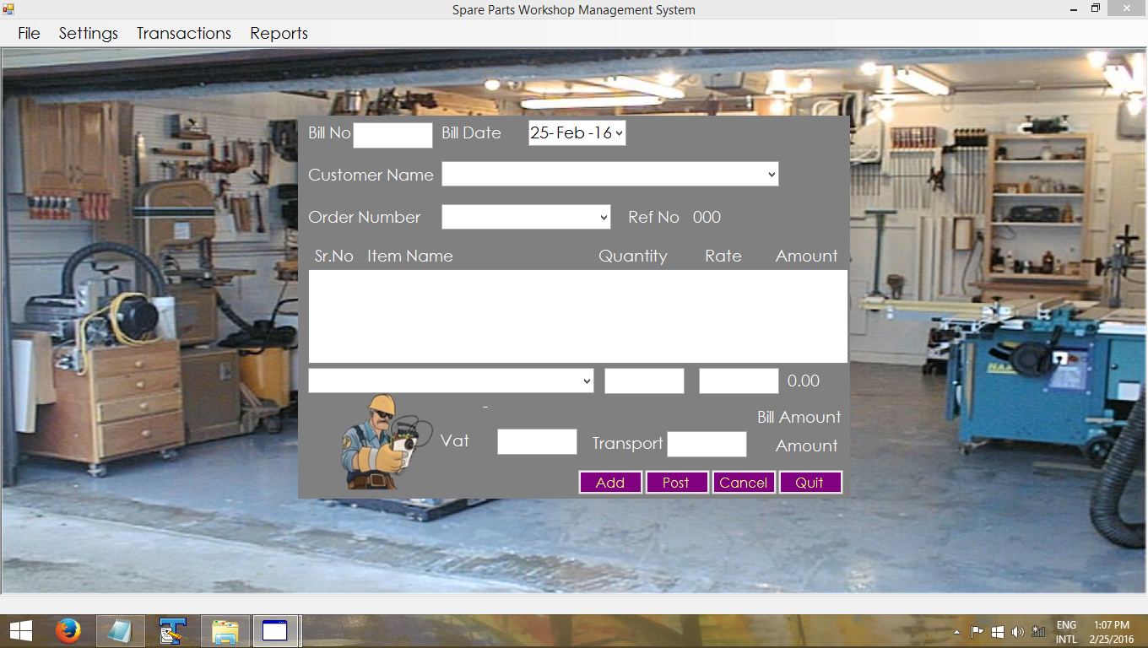

9.Customer Report

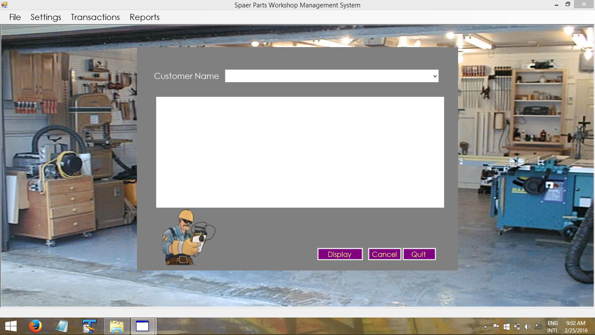

OUTPUT SCREEN

1. Customer Master Settings

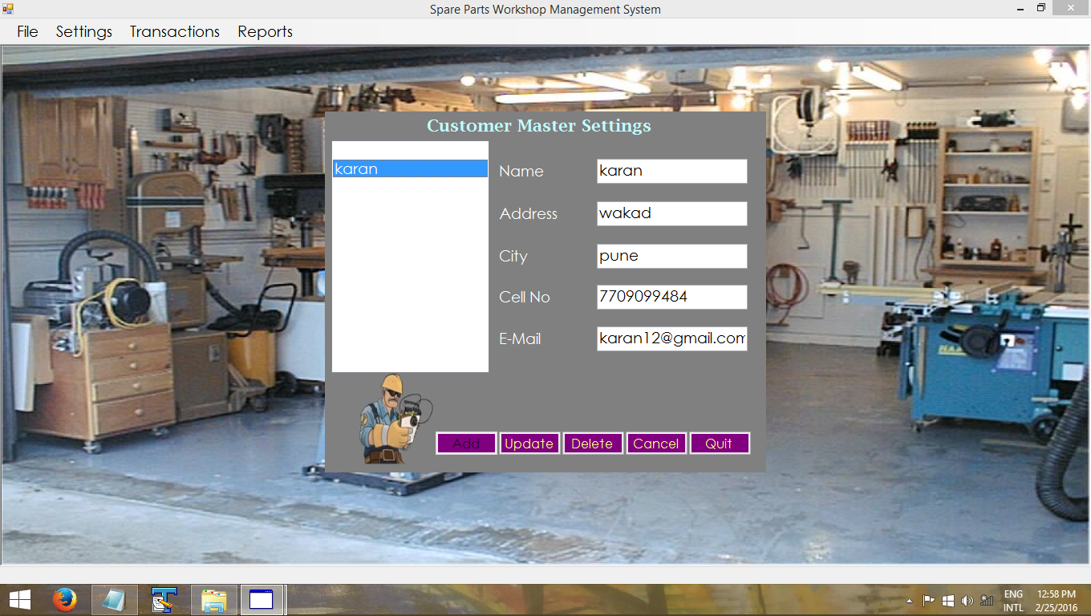

2.Item Master Settings

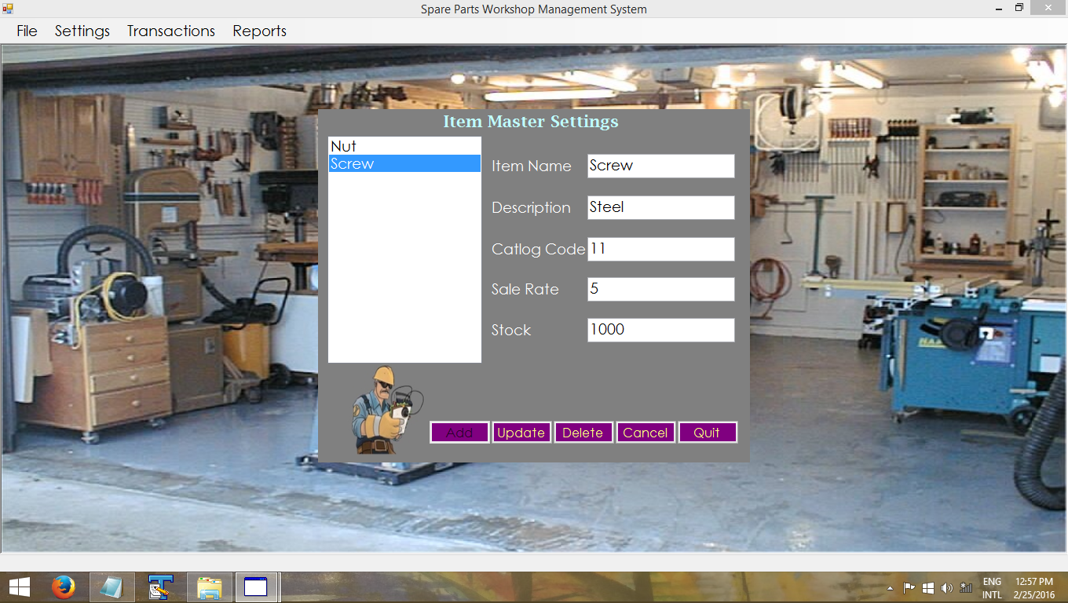

3.Raw Material Settings

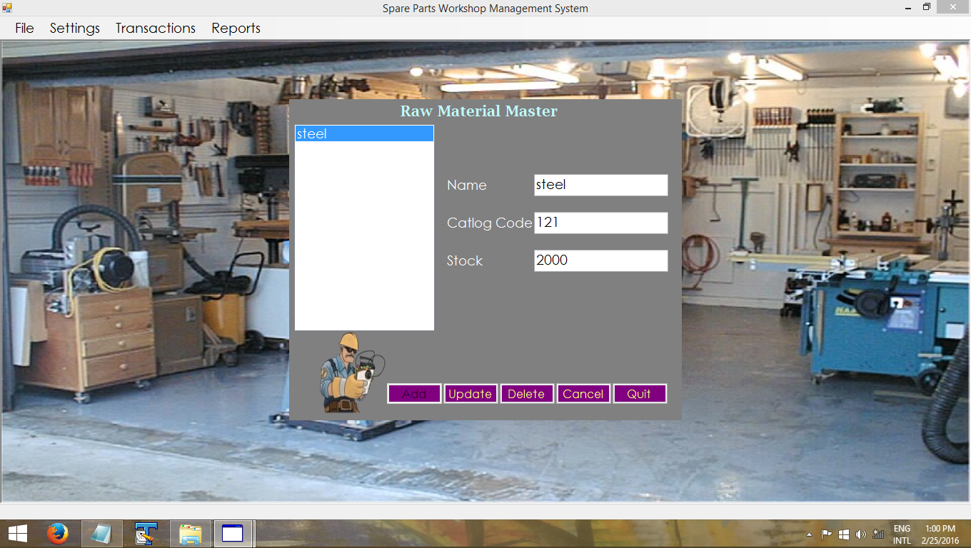

4.Supplier Master Settings

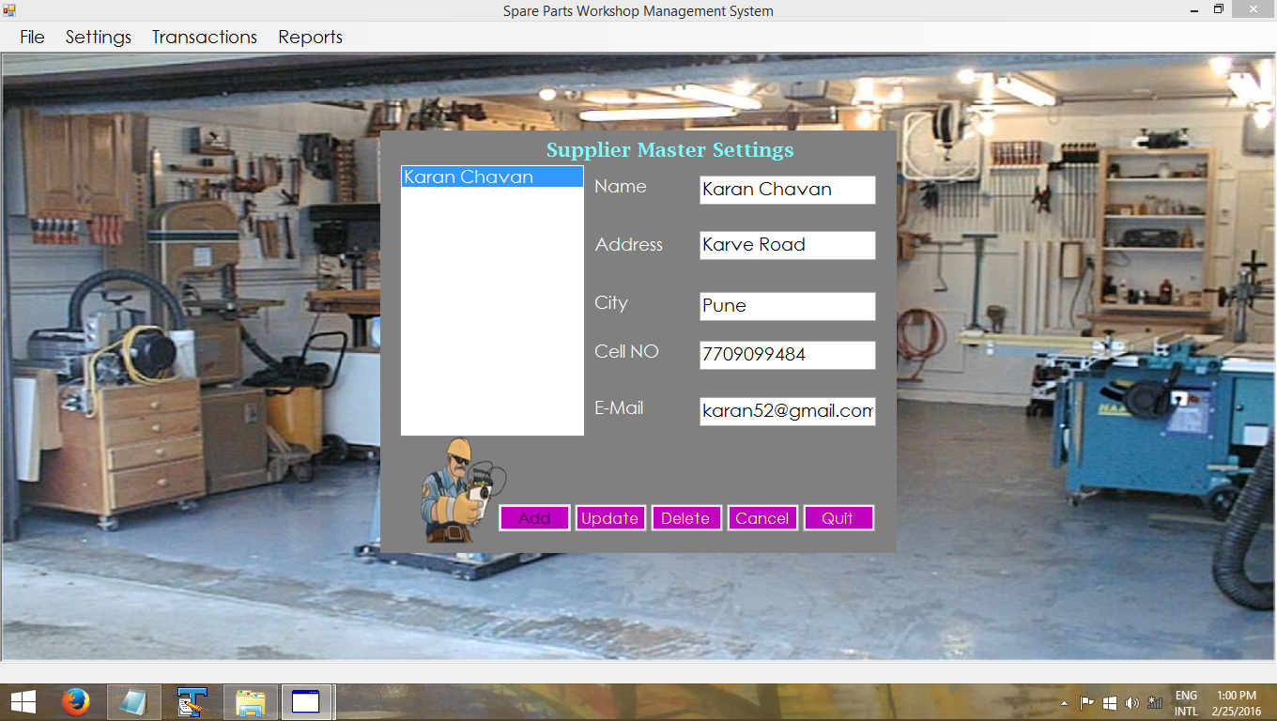

5.Order Transactions Form

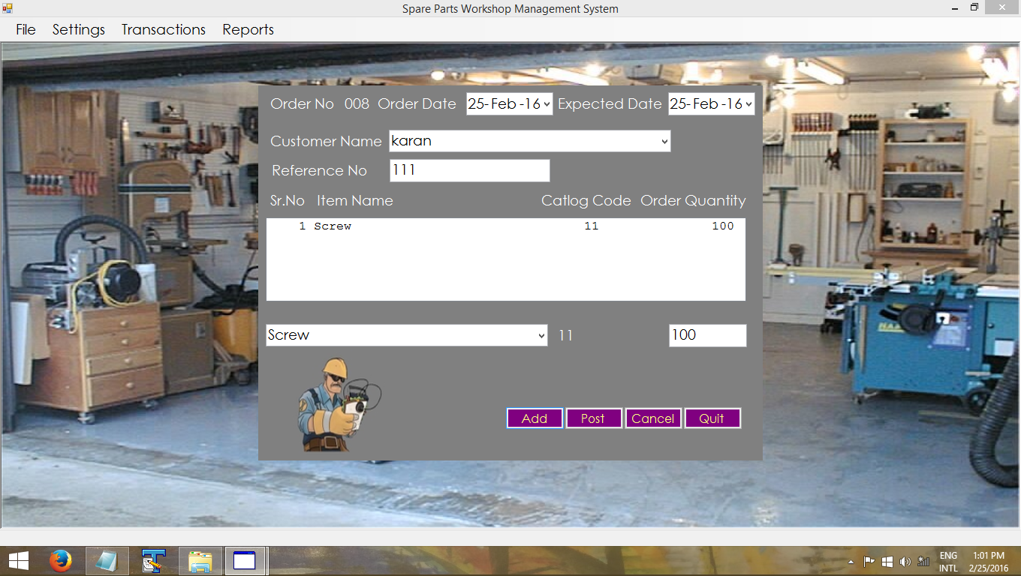

6.Production Form

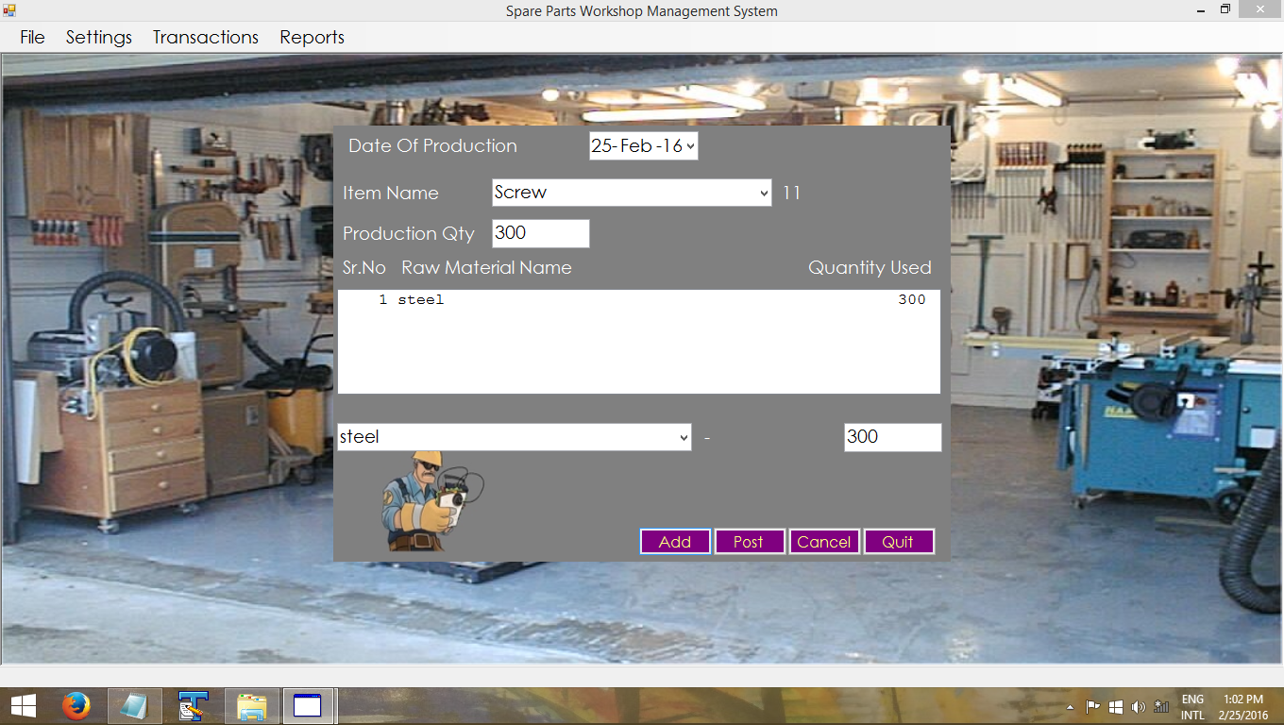

7.Sale Bill

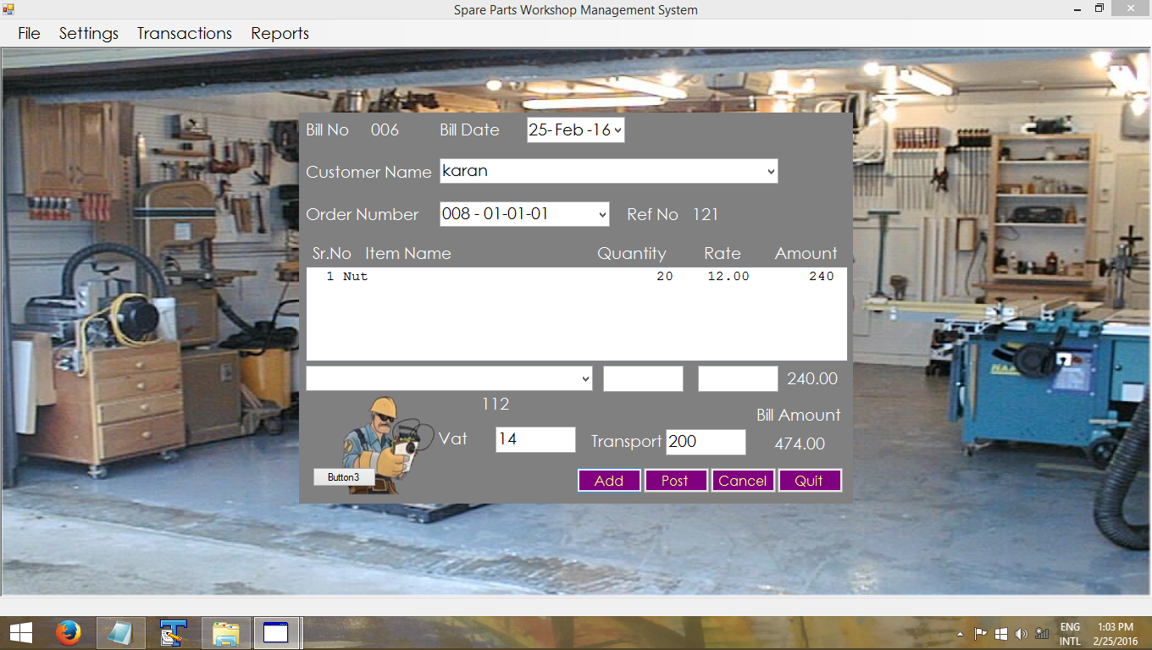

8.Raw Material Purchase

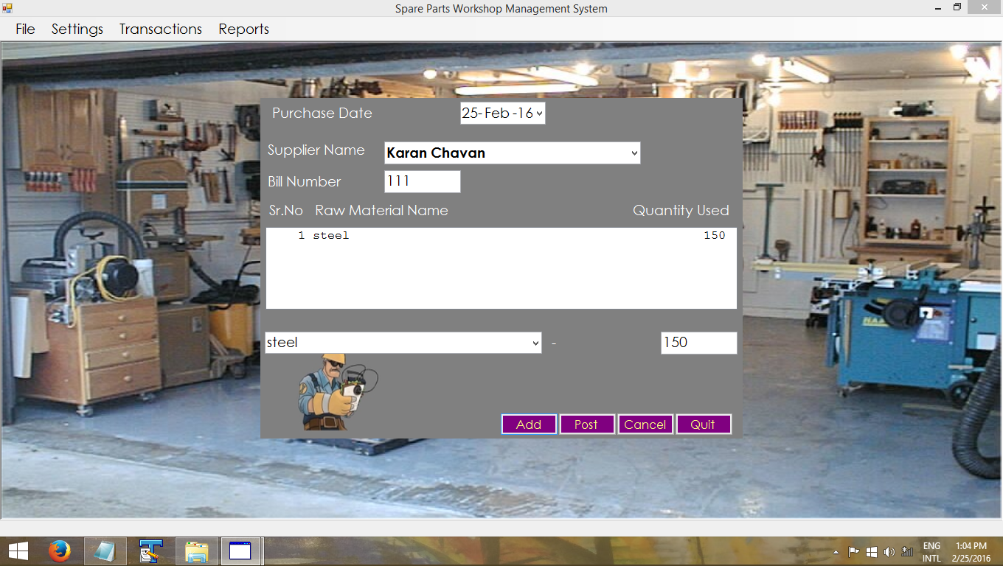

**Reports**

1.Customer Reports

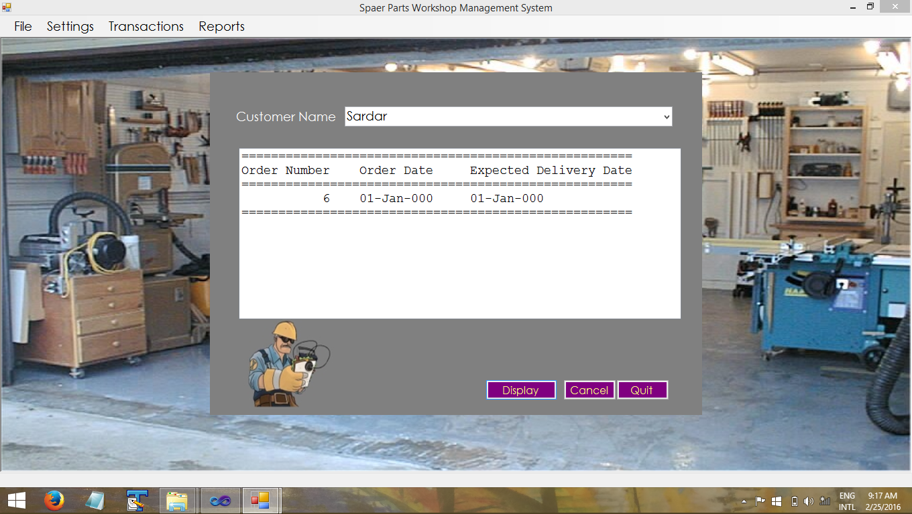

2.Raw Material Stock-Wise Report

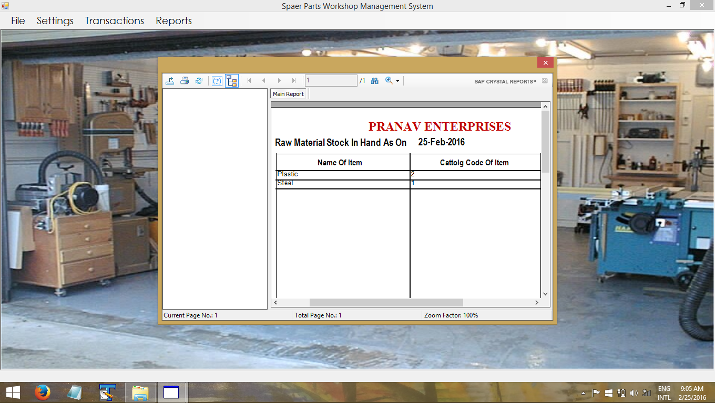

3.Order-Wise Delivery Reports

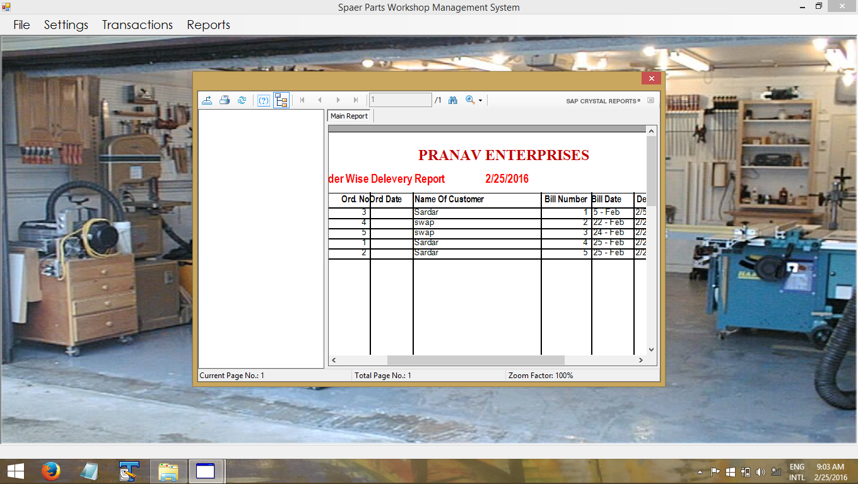

4.Bill Reports



5.Items Wise-Stock Report

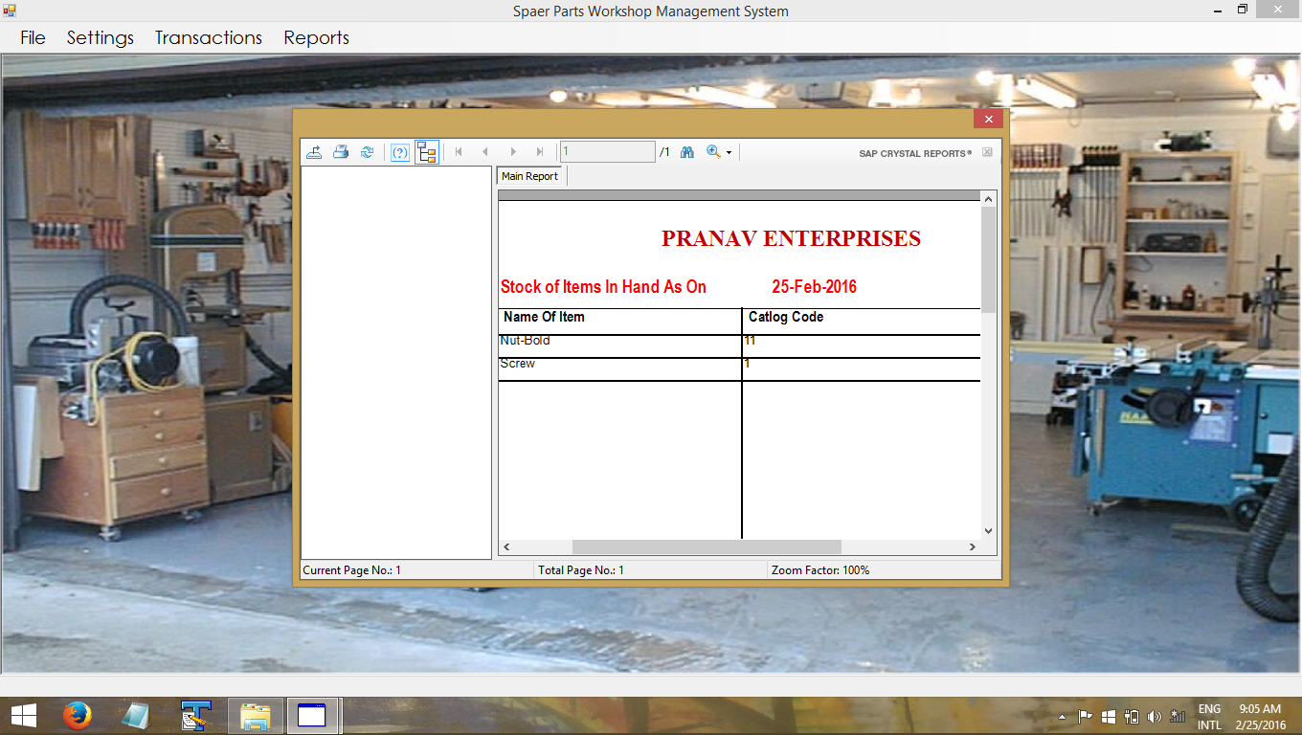

* Sample Code:-

PublicClass frmStartUp

PrivateSub ExitToolStripMenuItem_Click(ByVal sender As System.Object, ByVal e As System.EventArgs) Handles ExitToolStripMenuItem.Click

Application.Exit()

EndSub

PrivateSub frmStartUp_Load(ByVal sender As System.Object, ByVal e As System.EventArgs) HandlesMyBase.Load

DissableMenu()

EndSub

PrivateSub LogInToolStripMenuItem_Click(ByVal sender As System.Object, ByVal e As System.EventArgs) Handles LogInToolStripMenuItem.Click

Dim obj AsNew frmLogIn

obj.ShowDialog()

If UserName <>""Then

EnableMenu()

EndIf

EndSub

PrivateSub DissableMenu()

LogInToolStripMenuItem.Enabled = True

LogOutToolStripMenuItem.Enabled = False

SettingsToolStripMenuItem.Enabled = False

TransactionsToolStripMenuItem.Enabled = False

ReportsToolStripMenuItem.Enabled = False

EndSub

PrivateSub EnableMenu()

LogInToolStripMenuItem.Enabled = False

LogOutToolStripMenuItem.Enabled = True

SettingsToolStripMenuItem.Enabled = True

TransactionsToolStripMenuItem.Enabled = True

ReportsToolStripMenuItem.Enabled = True

EndSub

PrivateSub ItemMasterToolStripMenuItem_Click(ByVal sender As System.Object, ByVal e As System.EventArgs) Handles ItemMasterToolStripMenuItem.Click

Dim obj AsNew frmItemMaster

obj.ShowDialog()

EndSub

PrivateSub CustomerMasterToolStripMenuItem_Click(ByVal sender As System.Object, ByVal e As System.EventArgs) Handles CustomerMasterToolStripMenuItem.Click

Dim obj AsNew frmCustomerMaster

obj.ShowDialog()

EndSub

PrivateSub ToolStripMenuItem5_Click(ByVal sender As System.Object, ByVal e As System.EventArgs) Handles ToolStripMenuItem5.Click

Dim obj AsNew frmRawMaterialMaster

obj.ShowDialog()

EndSub

PrivateSub LogOutToolStripMenuItem_Click(ByVal sender As System.Object, ByVal e As System.EventArgs) Handles LogOutToolStripMenuItem.Click

DissableMenu()

EndSub

EndClass

* LIMITATIONS of Existing Process:
* The existing system is a manual process thus increasing human efforts.
* The existing system is more liable to errors and sometimes the approach to various problems is unstructured
* All the records are maintained on paper thus increasing the paperwork which is hard to maintain.
* There could be a possibility of loss of data due to any natural calamity which may result in loss of data that cannot be recovered
* If there is any change to be made in the process to inform all the branches becomes difficult
* Conclusion:-

“Satisfaction of a completing

A very good project”

This project has given us the world a good practical experience about how to communicate with the organization owners or employees listening to their ideas and implementing them with a practical ease.

This project has given us the exposure to the practical world and its difficulties. May be next time we will not face these much difficulties we faced during the implementation of this project.

And yes during the implementation of this project we come to know about the working style of the persons working in the industries and their way of representing the information.

Finally we would like to express that the project can be made with a practical knowledge and its application to the project.

* Future Enhancement:-

In Future the application can be converted into web based application so that many transactions such as payment or receipt of money can be done using online transaction. The application at he moment only looks into inventory part of Dal-Mill Management in future it can be integrated with the account part as well.

The application can also be made useful to manage the documents with the help of email system.

* Bibliography:-
* Books

1. Starting out with Visual Basic.Net Programming

-Tony Gaddis.

1. Software Engineering –A Practitioner’s Approach

-Roger Pressman.

* Web-Sites

1. www..w3school.com